1. Service provider/service partner’s queue page

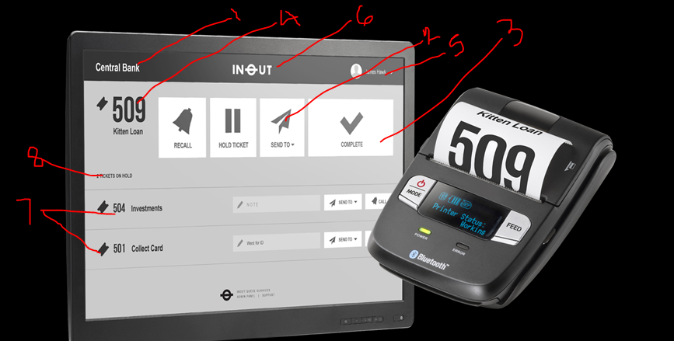

1. Branch name
2. Skip and return
3. Mark as complete
4. Ticket number currently getting a service
5. Logged in user
6. On-going queue
7. Queued ticket
8. No of tickets in the row
9. Customer queue status screen

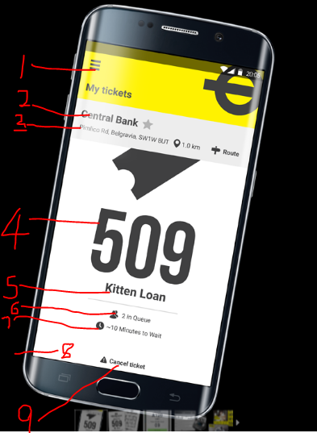

1. Option to other actions (schedule appointment, bookmarked saloons, etc)
2. Branch name
3. Branch address
4. Service start time
5. Ticket number
6. Estimated wait time
7. Service offering
8. Update appointment
9. Cancel ticket